Project Planning Phase

**Project Planning Template (Product Backlog, Sprint Planning, Stories, Story points)**

|  |  |
| --- | --- |
| Date | 08 November 2022 |
| Team ID | PNT2022TMID03339 |
| Project Name | Emerging Methods for Early Detection of  Forest Fire |
| Maximum Marks | 8 Marks |

# Product Backlog, Sprint Schedule, and Estimation (4 Marks)

|  |  |  |  |  |  |  |
| --- | --- | --- | --- | --- | --- | --- |
| **User Type** | **Functional Requirement (Epic)** | **User Story Number** | **User Story / Task** | **Acceptance criteria** | **Priority** | **Release** |
| Environmentalist | Collect the data | USN-1 | As an Environmentalist,it is necessary to collect the data of the forest which includes temperature,humidity,wind and rain of the forest | It is necessary to collect the right data else the prediction may become wrong | High | Sprint-1 |
|  |  | USN-2 | Evaluate Data set | Data is evaluated before processing | Medium | Sprint-1 |
|  |  | USN-3 | Identify algorithms that can be used for prediction | To collect the algorithm to identify the accuracy levelof each algorithms | Medium | Sprint-2 |
|  |  | USN-4 | Identify the accuracy of each algorithms | Accuracy of each algorithm-calculated so  that it is easy to obtain the most accurate output | High | Sprint-2 |
|  |  | USN-5 | Identify accuracy,precision,recall of each algorithms | These values are important for obtaining the right output | High | Sprint-3 |
|  |  | USN-6 | Outputs from each algorithm are obtained | It is highly used to predict  the effect and to take precautionary measures. | High | Sprint-4 |

**Project Tracker, Burndown Chart: (4 Marks)**

|  |  |  |  |  |  |  |
| --- | --- | --- | --- | --- | --- | --- |
| **Sprint** | **Total Story Points** | **Duration** | **Sprint Start Date** | **Sprint End Date (Planned)** | **Story Points Completed (as on Planned End Date)** | **Sprint Release Date (Actual)** |
| Sprint-1 | 20 | 4 Days | 31 Oct 2022 | 03 Nov 2022 |  | 8 Nov 2022 |
| Sprint-2 | 20 | 4 Days | 05 Nov 2022 | 08 Nov 2022 |  | 8 Nov 2022 |
| Sprint-3 | 20 | 4 Days | 10 Nov 2022 | 13 Nov 2022 |  |  |
| Sprint-4 | 20 | 4 Days | 15 Nov 2022 | 18 Nov 2022 |  |  |

**Burndown Chart:**

A burn down chart is a graphical representation of work left to do versus time. It is often used in agile [software development](https://www.visual-paradigm.com/scrum/what-is-agile-software-development/) methodologies such as [Scrum](https://www.visual-paradigm.com/scrum/scrum-in-3-minutes/). However, burn down charts can be applied to any project containing measurable progress over time.

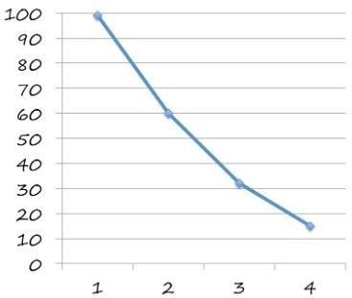

In our project, there are 4 sprint activities.

This chart is drawn by taking x->sprint and

y->pending hours.